Leading Educational Change Through Documenting and Transforming Institutional Teaching Culture

Florida Doci, Kaitlyn Gillard, Hoda Eiliat, Erika Kustra (University of Windsor)

ABSTRACT
Institutional culture helps define the nature of reality for the educators and learners within the institution. It provides a lens through which its members assign value to the various events and efforts of their institution (Bergquist & Pawlak, 2008). The success of educational leadership initiatives is influenced by the context of an institutional culture. Consequently, understanding and documenting institutional culture can provide benchmarks for institutions to work towards in their ongoing enhancement of teaching and learning, and sustenance of embedded leadership.
Currently, there are no existing large scale instruments to assess the institutional teaching culture in Canada. Our goal is to develop a process to examine, maintain and enhance the quality of teaching in post-secondary education. This workshop provides an overview of a project currently under development by eight Ontario institutions working collaboratively to identify a set of indicators and a survey tool that help define the value placed on an institutional teaching culture.

QUANTITATIVE INDICATORS
Input Indicators: Resources such as human, financial and physical involved in supporting an institutional program, activity or service.
Output Indicators: Data-driven outcomes produced.

QUALITATIVE INDICATORS
Outcome Indicators: Outcome indicators mainly focus on the quality of educational program, activity and service benefits for all stakeholders.
Process Indicators: Means and processes used to deliver educational programs, activities and services within the institutional environment.

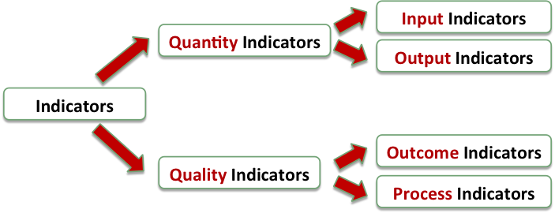

QUALITATIVE RESULTS

Faculty
Support for Teaching (ex. teaching resources)
Recognition of Teaching (ex. teaching awards)
Infrastructure (ex. student centred classrooms)
Research above Teaching (ex. PTR decisions)
Teaching Evaluations (ex. valid measures)

Graduate Student
Research-inspired and Innovative pedagogy
Support for Teaching (ex. training TAs and GAs)
Recognition of Teaching (ex. teaching awards)

Undergraduate Student
Current and Supported Best Practices
Professors’ Behaviours (ex. organization, passion)
Teacher Accessibility (ex. office hours, email)
Teaching Evaluations (ex. mid-term feedback)
Implementation of Student Feedback

QUANTITATIVE RESULTS

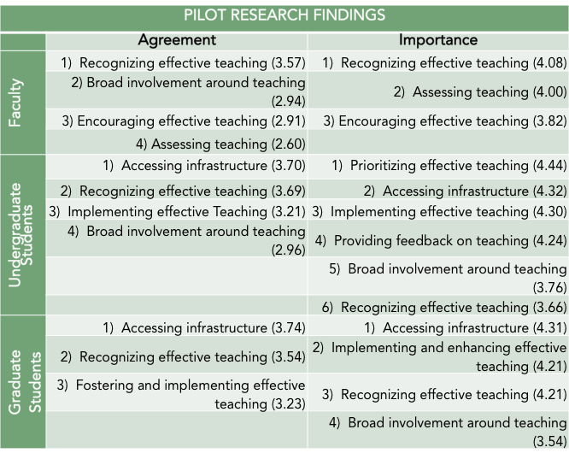

CONTACT INFORMATION
Dr. Erika Kustra, Director, Teaching and Learning Development Centre for Teaching and Learning, University of Windsor, Phone: (519) 253 3000 Ex. 4842, Email: kustraed@uwindsor.ca

Website : uwindsor.ca/teachingculture

ACKNOWLEDGEMENTS
Funding granted by the Ministry of Training, Colleges and Universities, Government of Ontario. In kind support provided by:

